How to forward your College of the Desert mycod.us email to another email account
- Log into your MyCOD.us email account from the MyCOD Student Portal
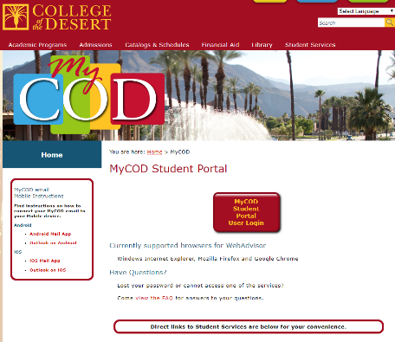
- Once you login, “Quick Launch” will show on the right side. Select the “mycod.us Email” button and login with your mycod email address
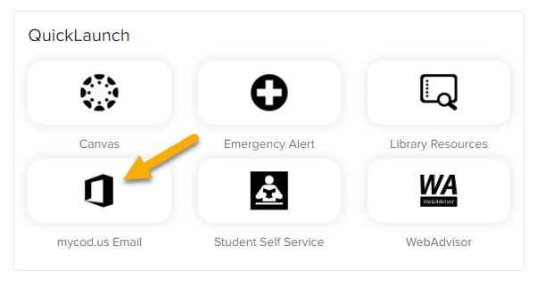
- Click on the Settings icon in upper right (shaped like a gear)
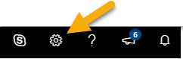
- Click on “View all Outlook settings”
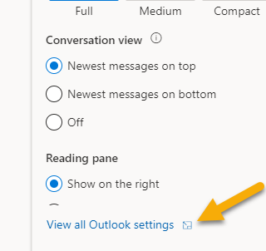
- Select “Forwarding” from the Settings
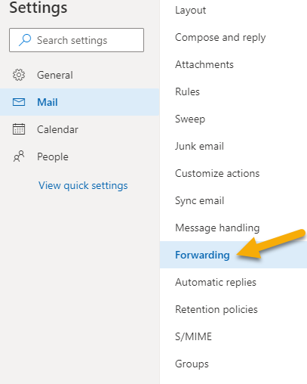
- Check the box next to “Enable Forwarding” and enter the email address you want to forward to
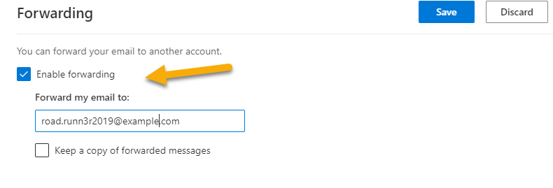
- Very Important – Make sure to check the box next to “Keep a copy of forwarded messages” to ensure you will always have a copy of emails from COD
- Click “Save” in the upper right to save your changes and to activate the email forward
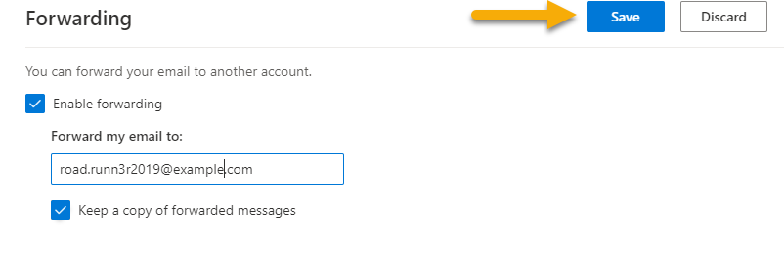
Rev 10/15/19

